DIGITAL LOGIC DESIGN LAB (EET1211)

LAB II: Examine & Analyze Advantages of Gate Level Minimization for Boolean Function Using HDL

Siksha ‘O’ Anusandhan Deemed to be University, Bhubaneswar

Branch: Section:
S. No. | Name | Registration No. | Signature
 | Amrit Kafle | 19410121179

Marks: ______/10

Remarks:

Teacher’s Signature

I. OBJECTIVE:

- Construct a circuit using basic gates that implements the Boolean function given below and record the output for all sets of input.
𝐹 = 𝐴𝐵 + 𝐴𝐵′𝐶
a. Simplify the Boolean function using minimization technique.
b. Construct the circuit for the simplified expression using basic gates & verify the truth table.
c. Write HDL code for the function F and for the simplified expression.

2. Simplify the following Boolean functions to a minimum number of literals and write HDL program for each functions.
a) F= XY +X′Z+YZ
b) F= (X′Y′+Z) ′+Z+XY+WZ

- Consider two Boolean functions in sum-of-min terms form:
F1 (A, B, C, D) = (0, 1, 2, 3, 4, 6, 8, 9, 10, 11)
F2 (A, B, C, D) = (3, 5, 7, 8, 10, 11, 13, 15)
a. Implement both the functions using a minimum number of NAND ICs & verify the truth tables.
b. Write HDL code for the functions

II. PRE-LAB

- For Obj. 1:
a. Draw the circuit diagram.
b. Obtain the truth table for F as function of 3 inputs.
c. Simplify the Boolean function using Boolean algebra rules & verify the correctness of the simplified expression using truth table.
d. Draw the logic diagram of simplified Boolean expression

For Obj. 2:

a) Draw the circuit diagram and obtain the truth table for all input combinations.
b) Simply the functions.
c) Draw the circuit & write truth table for minimized functions.

For Obj. 3:

a) Simplify the given expressions using k-map.
b) Obtain a composite logic diagram with four inputs, A, B, C and D, and two outputs, F1, and F2. Obtain truth tables for both the functions.

III. LAB:

HDL Program:

1 =>

Minimization:

AB + AB’C
= A(B+B’C)
=A(B + C)

module Q1(
input a,
input b,
input c,
output f
);

assign f = a && (b || c);
endmodule

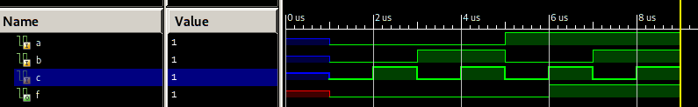

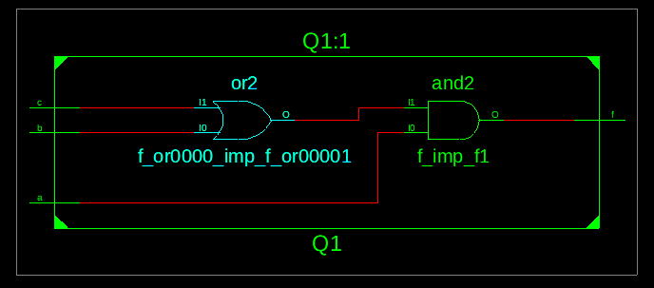

A | B | C | F
0 | 0 | 0 | 0
0 | 0 | 1 | 0
0 | 1 | 0 | 0
0 | 1 | 1 | 0
1 | 0 | 0 | 0
1 | 0 | 1 | 1
1 | 1 | 0 | 1
1 | 1 | 1 | 1

2a =>

XY + X’Z +YZ
=XY + X’Z + YZ(X + X’)
=XY + X’Z + XYZ + X’YZ
= XY( 1 + Z ) + X’Z( 1 + Y)
=XY + X’Z

module a(
input x,
input y,
input z,
output f
);

assign f = (x&y)|((!x)&z);
endmodule

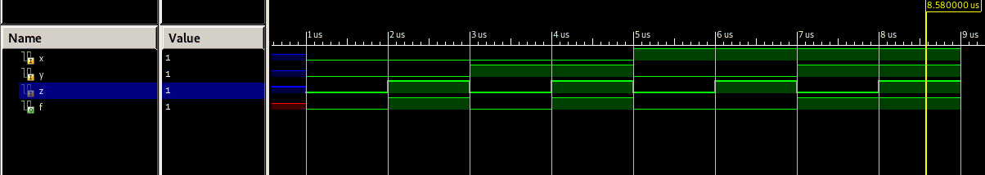

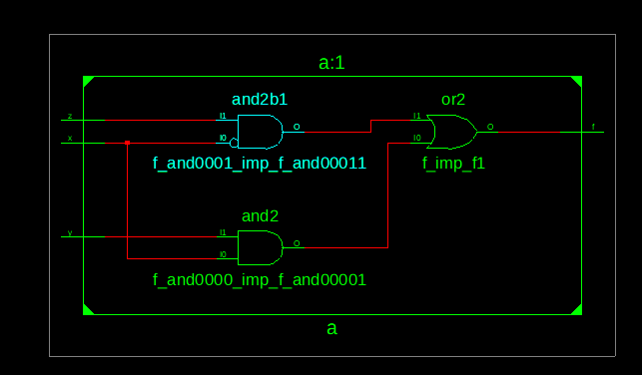

A | B | C | F
0 | 0 | 0 | 0
0 | 0 | 1 | 1
0 | 1 | 0 | 0
0 | 1 | 1 | 1
1 | 0 | 0 | 0
1 | 0 | 1 | 0
1 | 1 | 0 | 1
1 | 1 | 1 | 1

2b=>

F= (X′Y′+Z) ′+Z+XY+WZ)
= (X’Y’)’.Z’ + Z + XY + WZ
= (X + y).Z’ + Z + XY + WZ
= (X + Y).Z’ + Z(1+W) + XY
= (X + Y + Z)(Z’ + Z) + XY
= X + Y + Z

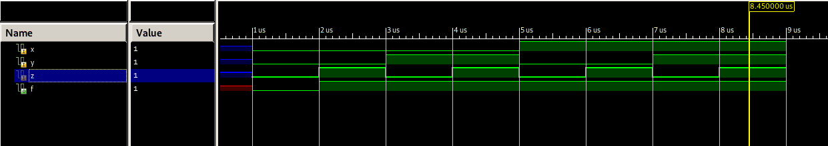

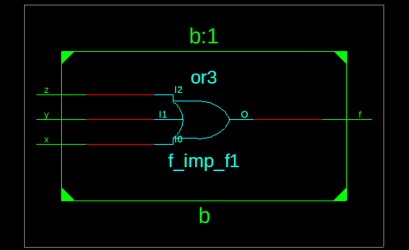

module b(
input x,
input y,
input z,
output f
);
assign f = x || y || z;
endmodule

X | Y | Z | F
0 | 0 | 0 | 0
0 | 0 | 1 | 1
0 | 1 | 0 | 1
0 | 1 | 1 | 1
1 | 0 | 0 | 1
1 | 0 | 1 | 1
1 | 1 | 0 | 1
1 | 1 | 1 | 1

Observation:

Conclusion:

IV. POST LAB:

1. What is the advantage of Boolean laws?
2. What is a K-map? What are its advantages and disadvantages?
3. What ways can Boolean expressions be represented?
4. Implement two input Ex-NOR gate using minimum number of two input NOR gates.

Answers:
1. => Boolean laws help us to minimize boolean expressions.
2. =>
3. =>
4. =>

